Form 7 “B”

Date: 6.12.2014

The theme of the lesson: English schools

Цель урока: формирование речевой компетентности учащихся.

Задачи:

Обучающая

- обобщение материала по теме и формирование представления о типах английских школ;

- отработка интонации и произношения;

- развитие речевых навыков

- навыков аудирования

Развивающая

- развитие навыков групповой, фронтальной работы;

- формирование информационно – коммуникационной компетентности;

- развитие языковой догадки, мышления, воображения, умения

Воспитательная

- создание положительной мотивации к изучению иностранного языка;

- расширение интереса учащихся к предмету при помощи информационно – коммуникационных технологий;

- стимулирование учащихся к работе в группе;

- воспитание интереса к школьной жизни своих сверстников за рубежом.

1. **Organizational moment.**

Good morning, children! I’m glad to see you. How are you, today?

Now tell me please, what’s the date today? What’s the day today?– (Pupils’ answers): …

We are going to continue our talk about English schools.

We’ll speak about different types of English schools. You will know something interesting and new for you. I hope that our co –operation will be important for you and me.

1. **Warm up**

***Флипчарт 1***

Match the words: noun, verb, adjective

|  |  |  |
| --- | --- | --- |
| noun | verb | adjective |
| Topic  Computer  Discussion  Cloak-room  Subject  uniform | Start  Comprise  Last  Locate  Create  attend | Primary  Secondary  Famous  Widespread  Private  Compulsory |

1. **New theme**

Video “English schools”

**Speaking**

|  |
| --- |
| When do children start going to school in Britain? |
| When do pupils finish primary school? |
| How many years do pupils study in secondary school? |
| When does compulsory education begin? |
| What are the types of secondary school in England? |
| What are the “core” subjects? |
| How long does primary education last? |
| When do lessons start? |

1. 5
2. 11-12
3. 5
4. 5
5. Grammar, modern, comprehensive
6. English, Maths, Science
7. 6
8. 9.00

***Флипчарт 2***

*-Now look at the blackboard and complete the diagram.*

**The diagram of the system of education in Great Britain**

English schools

Private schools

State schools

Secondary schools

Junior schools

Infant school

Independent schools

Public schools

Modern schools

Grammar schools

Comprehensive schools

**Work in groups.**

Task. True or false. Correct false sentences.

1. In Great Britain children start going to school when they are seven. (five)
2. Compulsory education begins at the age of 11. (5)
3. Primary education lasts for six years.
4. Boys and girls study at junior school for four years.
5. English, Maths and Science are called “core” subjects.
6. Boys and girls study together at private schools. (do not study)
7. Compulsory education begins at the age of five when children go to primary school.

**Reading**

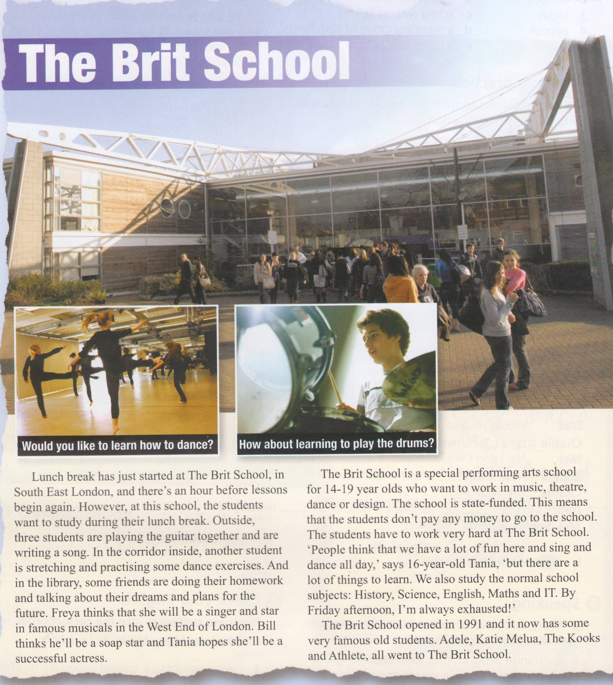

Answer the questions

1. Where is The Brit School?
2. How long is the lunch bread?
3. How old are the students at the school?
4. What subjects do students study?
5. When did the school open?
6. In South East London
7. An hour
8. 14-19
9. History, Science, English, Maths, IT
10. In 1991

**Listening**

Listen and complete the dialogue.

**Teacher** So, Tim, why do you want to come to this school?

**Tim**  Well, I really love __________ and I think that this school is a great place to learn. I want to study ________ here.

**Teacher** Hmm. I see. What job do you think you'll have in the future?

**Tim**  I hope I'll________ a professional singer. I think I'll be in a band and we'll_______ and _______ our own songs.

**Teacher** Do you ____________ your music at home ?

**Tim** Yes, I do. I sing every day, even in the holidays. And I'm also ________ to play the guitar.

**Teacher** Who is your favourite singer?

**Tim**  I really love Justin Timberlake. I think he's got an amazing voice and he's a great______________too.

**Teacher** So, Tim, why do you want to come to this school?

**Tim**  Well, I really love **singing** and I think that this school is a great place to learn. I want to study **misic** here.

**Teacher** Hmm. I see. What job do you think you'll have in the future?

**Tim**  I hope I'll **be** a professional singer. I think I'll be in a band and we'll **write** and **perform** our own songs.

**Teacher** Do you **practise** your music at home ?

**Tim** Yes, I do. I sing every day, even in the holidays. And I'm also **learning** to play the guitar.

**Teacher** Who is your favourite singer?

**Tim**  I really love Justin Timberlake. I think he's got an amazing voice and he's a great **dancer** too.

**Project**

Students work in groups and make project

Group #1 “Eton School”

Group # 2 “Harrow School”

Group # 3 “Sherborne School for Girls”

1. Evaluation
2. Home task

Project “School of the future”

**Appendix 1**

**Eton**

Do you know Eton? It’s the most famous public school. A year at Eton costs 34000 $. A lot of important people used to be students there. It’s an all boys school. Prince William, the Queen’s grandson went to Eton, too. But if you take a special exam and if your results are very good, you get a scholarship. In this case you don’t have to pay to go there.

Eton is one of the oldest and best-known public schools for boys, at the town of Eton on the river Thames. Its students are largely from aristocratic and upper – class families. The school was founded in 1440. Boys usually stay at Eton for five years (between the ages of 13 and 18). Eton provides fine teaching facilities in science, in language, computing and design. There are two major libraries, College Library and School Library, but also numerous subject libraries.

Sport plays are very important part in the life of Eton. The principal games are rugby, football, cricket and rowing. Athletics, swimming, golf, squash, tennis, fencing, judo, and Karate are all very popular.

The boys are offered a very wide range of opportunities for spare time activities: art, sculpture, woodwork, metalwork and silver work. Besides almost any musical instrument can be learnt. There are also fifty societies run by the boys themselves.

Many famous people of Britain studies at Eton, among them twenty of Britain’s Prime Ministers. There were future writers among the students of Eton from Thomas Gray, Percy Bysshe Shelley and Henry Fielding to Aldus Huxley and George Orwell.

**Appendix 2**

**Harrow school**

Harrow school is an English independent school for boys situated in the town of Harrow, in north-west London. Harrow has educated boys since 1243 but was officially founded by John Lyon under a Royal Charter of Elizabeth I in 1572.

The school as enrollment of approximately 800 boys spread across twelve boarding houses, all of whom board full time.

Boys at Harrow have two uniforms.

Everyday dress, worn to most lessons, consists of a white shirt, black silk tie, grey trousers, black shoes, blue jumper, a dark blue woolen uniform jacket, the school blue and white scarf on cold days and, notably, a boater style straw hat with a dark blue band.

An alternative uniform, Sunday dress, worn every Sunday and for public engagements, consists of a morning suit; a black tailcoat, pinstriped trousers, a black waistcoat, black tie, braces and a white shirt.

Harrow School has 24 tennis court which include acrylic, hard and synthetic lawn which belong to Harrow Lawn Tennis Club.

Harrow is not built on a campus: it is fully integrated into surrounding area; there are private houses and shops on the hill, and the main road through the hill is a normal public highway and indeed a bus route.

The school is made up of some 400 acres of playing fields, tennis courts, golf course, woodland and gardens.

**Appendix 3**

**Sherborne School for Girls**

**Sherborne School for Girls**, informally known as **Sherborne Girls,** is an independent day and [boarding school](http://en.wikipedia.org/wiki/Boarding_school) for girls. Located in [Sherborne](http://en.wikipedia.org/wiki/Sherborne), North [Dorset](http://en.wikipedia.org/wiki/Dorset), **England**. The school was founded in **1899 by Mr. and Mrs. Kenelm Wingfield Digby**. There are currently **440 pupils** attending Sherborne Girls, with over 90 percent of students living on campus and residing in the seven boarding houses.

All girls are required to take **English, Maths, a Science subject, Religion and a Foreign Language**. Both schools also collaborate in various school activities and functions such as **theatre** productions, joint societies and social activities. The campus includes **Oxley Sports centre**, which opened in 2007 with a six lane swimming **pool, fully equipped fitness suite, squash courts, badminton courts, a floodlit Astro Turf hockey pitch, climbing wall, grass pitches and dance studio.**

Sherborne Girls is a mainly boarding school for girls aged between **11 and 18**. It has a fine academic reputation of which it is justly proud, and has been in the forefront of girls’ education in Britain for over **100 years**. The school is situated in beautiful grounds on the edge of the attractive Dorset town of Sherborne which enjoys a temperate climate. There are good road and rail links including direct rail links with London and Heathrow airport. The school provides a rich environment for the development of well-educated, confident and caring young women who are committed to making significant and positive contributions to the world in which they live. The school honours the timeless traditions of honesty, and integrity together with the vital characteristics of compassion, tolerance, and mutual respect.