Warming up:

[ W ]

While we were walking
we were watching
window washers
wash Washington’s
windows
with warm washing water.

Theme of the lesson is

Oculist businesswoman programmer

Driver taxi-driver aeronaut

Veterinary Doctor Broker


Worker Engineer Guide

Teacher Builder Office-worker

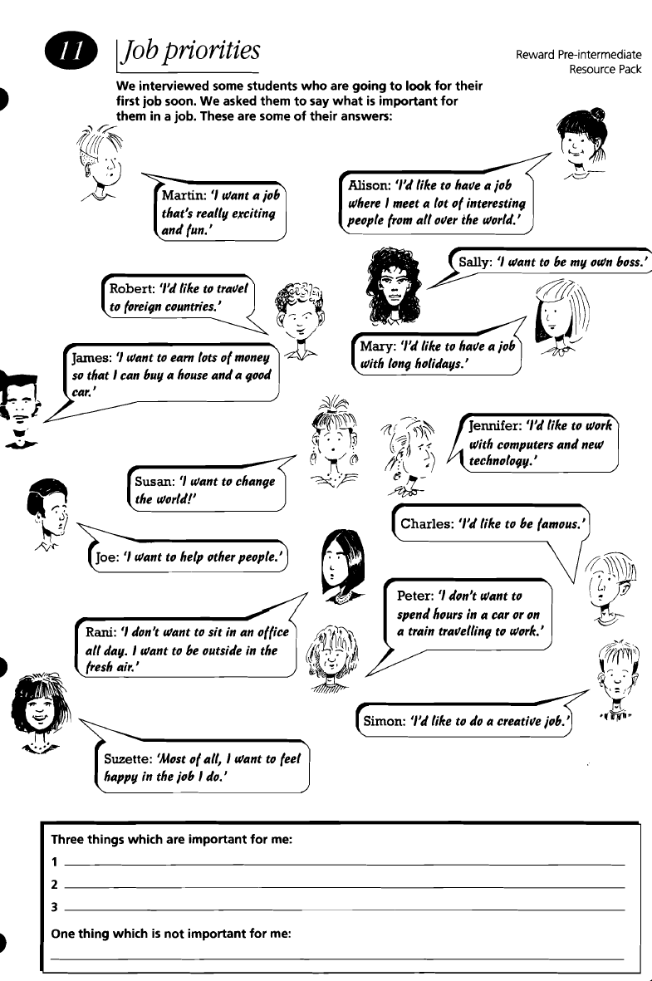

Definitions:

- when you work the whole day (usually 8 hours a day)

- when you work only few hours a day (usually you discuss it before taking the job place)

Questionnaire

1. Are you looking for:
a) a full-time job
b) a part-time job

2. Which of these is the most important for you?
(Please tick from number 1 till 5 in order of importance)

Money [ ]
People [ ]
Security [ ]
An interesting job [ ]

3. Do you like?
Yes No
a) meeting people? [ ] [ ]
b) working alone? [ ] [ ]
c) working with other people? [ ] [ ]
d) working with your hands? [ ] [ ]
e) traveling [ ] [ ]

4. What do you like do in your free time?

_________________________________________________________________________________________________________________________________________________________________________________________________________________________________________________________________________

Esope’s fable
The farmer’s treasure

A farmer

Talk with the father

A treasure in
the field
finding of treasure

no gold, no silver

the rich harvest

father’s treasure
is work
Conclusion
(proverb)

One upon a time there lived one farmer. He was an old man about 60 years old. He lived on a beautiful and big farm with his three sons.
One day when he understood the he was going to die he asked his sons to come to speak to him. They couldn’t understand what had happened and went to their father.
The farmer said them that there was a treasure in their field but he didn’t say them where exactly it was and died.
The field was very big and the sons were very lazy. They didn’t want to dig the whole field but they wanted to find treasure very much. So they began to dig and try to find a treasure. But there was nothing there.
Some time later one of the sons told that there was no gold, no silver. They looked at the field and saw that it was all dug. Then they decided to plant wheat.
Three months later they had good harvest. They gathered in the harvest and wet to the market to sell it. They sold all harvest and had a great amount of money. Only then all the sons understood that their father’s treasure was work.
After that they understood that work has a bitter root but sweet fruit.
