Общеобразовательная средняя школа № 82

Открытый урок
Тема: Food
Цель: развивать интерес к изучению английского языка.
Задачи:
- Совершенствовать лексические навыки, применяя их в различных ситуациях;
- Развивать навыки чтения, письма и говорения;
- Прививать чувство ответственного отношения к своему здоровью, употребляя полезную еду.
Формы: общеклассные, индивидуальные.
Методы: наглядные, практические, словесные.
Тип урока: урок - закрепление
Класс: 6 «А»
Дата: 6.11.2010
Учитель английского языка: Мауль Н.И.

Караганда 2010
The project of the lesson:
I. Organizational moment.
Good morning, children. How are you? What is the date today? What is the day today? What is the weather like today? The theme of our lesson is “Food”.
II. There are many poems about food and we know one of them.
Let`s begin with the poem.
Some of us like brown bread,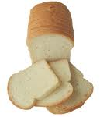
Some of us like white,
Some of us eat a lot of meat, 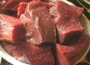
Some don`t think it`s right.
Some of us like apples,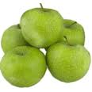
Some drink juice 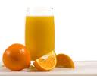 at night,
Some of us eat many sweets,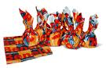
Some don`t think it`s right.
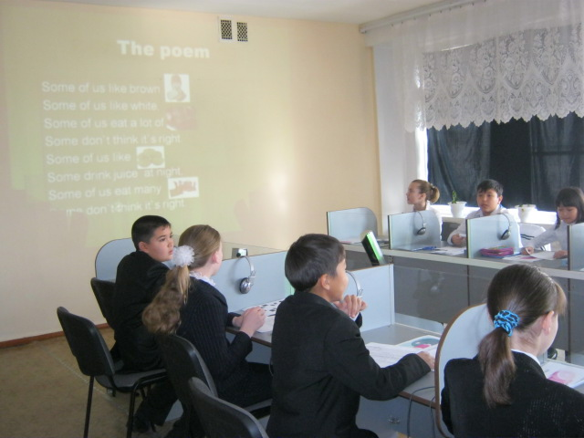
III. Listen to the tape.
Meat, chicken, vegetable, fruit, salad, bread, butter, salt, pepper, mustard, coffee, tea. 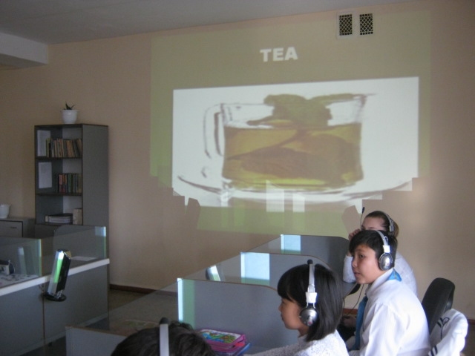
IV. Repeat after the tape and look at the pictures of food at the interactive board.

V. You have the cards you must cross the odd pictures.
meat bread 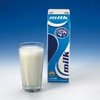 milk

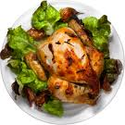 chicken 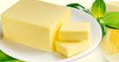 butter 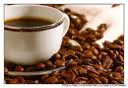coffee
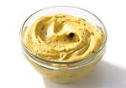mustard 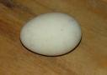 egg 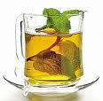 tea
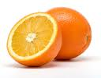 orange 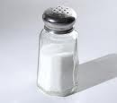salt
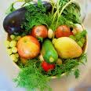 vegetable 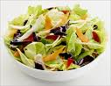salad
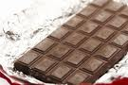chocolate 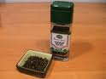pepper
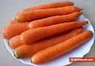 carrot 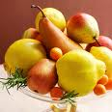fruit

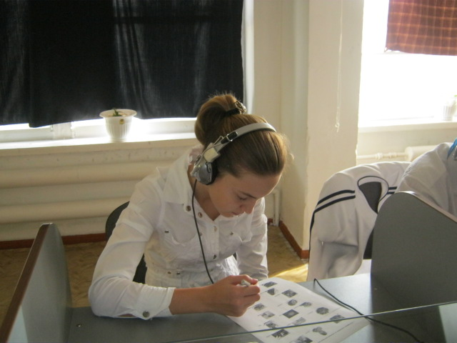

VI. Speaking.
I have some riddles about food. Let`s try to guess them.
- It is green and long. (cucumber)
- It is yellow and long. It is tasty. (banana)
- It is big and round, green outside and red inside. (watermelon)
- It is white outside and yellow inside. (egg)
- It is white and sweet. All children like it. We usually put into tea. (sugar)
- It is red and round. We make salad from it. (tomato)
- It is white. Little children usually drink it. (milk)
- It is white, sweet and cold. It is very tasty and all the children like it very much. (ice – cream)
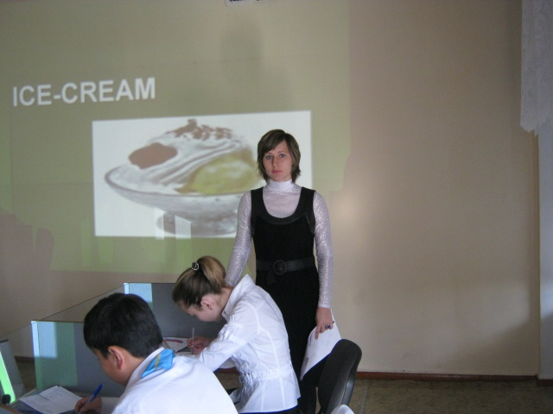

VII. Writing.
Now, please, take your crosswords and write all the words about food that you can find in them.
V | D | H | Т | F | R | U | I | Т | М
E | M | U | S | Т | А | R | D | V | L
G | F | С | X | М | К | J | Т | В | С
E | G | M | Е | А | T | U | I | S | Z
T | P | C | О | F | F | Е | Е | А | Р
A | E | H | Р | I | О | Y | Т | L | I
В | P | B | J | С | G | В | R | А | О
L | P | U | R | Н | F | R | Е | D | Р
E | E | T | Е | I | В | Е | D | F | D
S | R | T | U | С | М | А | Т | Е | А
W | G | Е | T | К | D | D | G | F | D
A | H | R | Q | Е | А | F | С | V | S
F | J | N | L | N | S | S | А | L | T

(cucumber, potato, pumpkin, peach, tangerine, cherry, sausage, bacon, cheese, sugar, juice, chocolate)
You could find all twelce names of food. You are good boys and girls.
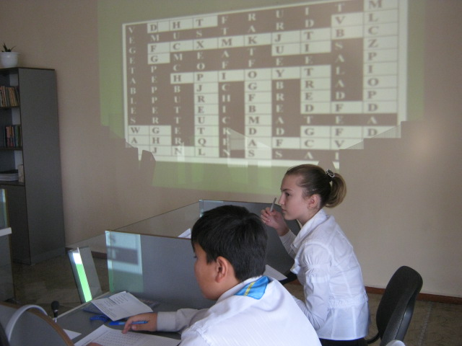
VII. Listening.
The pupils of our class prepared some poems about food. Now let`s listen to them very attentively. Then you must take te picture of the names of food which you have listened from these poems and clip it on the blackboard.
***
Jonathan Beam
Jonathat Beam
Likes ice- cream
And he is in bed today.
He doesn`t eat,
He doesn`t drink,
He doesn`t want to play.
***
The world
If all the world were apple – pie,
And all the sea were ink,
And all the trees were bread and cheese,
What should we have to drink?

***
Tea
Tea is prepared from the leaf of a tree;
Honey is gathered and made by the bee.
Butter is made from milk of the cow;
Pork is the fresh of the pig or the sow.
The juice of the apple makes cider so fine,
The juice of the grapes makes red and white wine.
***
Robin
Robin, Robin, what a man!
He eats as much as no one can.
He ate a lot of fish, he ate a lot of meat.
He ate a lot of ice-cream and a sweet.
He ate a lot of porridge and ten eggs
And all the cookies Mother has.
He drank a lot of juice, he ate a cake
Then said: “I have a stomach-ache.”

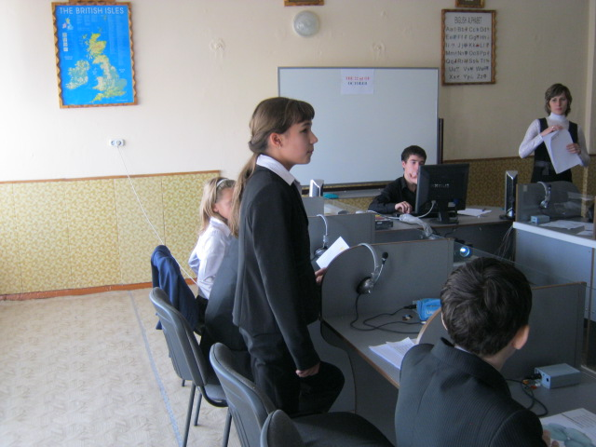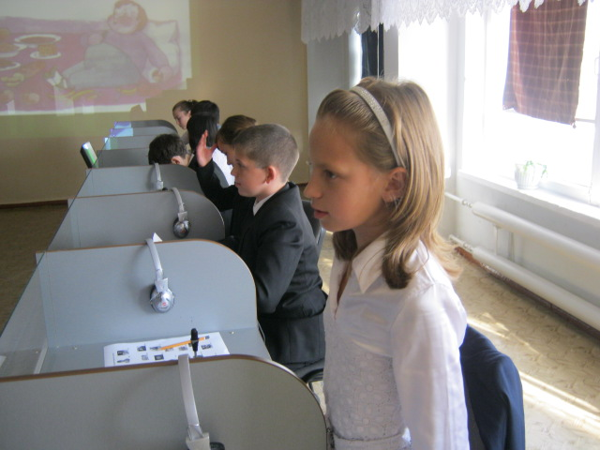
Do you listen to fish?
Yes, I do.
No, I don`t.
(Key: ice-cream, bread, cheese, tea, butter, milk, juice, apple, fish, meat, eggs.)
VIII. Let`s play. “Whose nose is better?” Guess what fruit or vegetable it is.
(Pupils may be smells of a cucumber, a garlic, an onion and etc. )
IX. Reading.
You have the text. Its name is “Food for life”. Let`s read and translate it.
Food for life
People cannot live without food. Where does our food come from? Meat comes from animals. People eat domestic birds too. Eggs come from birds. Milk comes from cows. From milk people make butter and cheese.
From plants we get fruit and vegetables. A lot of fruit grows on tree: apples, oranges and bananas. Some plants have fruit too, like the coffee plant.
Tea comes from a plant too, but it is not a fruit. We make tea from the leaves of a plant, so tea is a vegetable!
Some people grow their food, but usually we buy it.
Remember to buy and eat the right food! Remember the proverb: An apple a day keeps the doctor away. Eat a lot of fruit and vegetables! Drink milk and juice! They have a lot of vitamins.
X. Writing.
Find the names of food in the text and write out them.
Meat, eggs, milk, butter, cheese, fruit, vegetables, apples, oranges, bananas, coffee, tea.
XI. Speaking.
Answer the questions.
- What do we get from animals?
- What do we get from birds?
- What do we get from cow?
- What do we get from plants?
- What must we remember?
XII. Writing.
True or False.
- From plants we get fruit and vegetables. T
- People can live without food. F
- Eggs come from birds. T
- From milk people don`t make butter and cheese. F
- Remember to buy and eat the right food! T
- People don`t eat domestic birds too. F
- Meat comes from animals. T
- Some plants have fruit too, like the coffee plant. T
XIII. Let`s play.
Put the button on the picture of the name of food which you hear.
Then cry: “Dinner time”.
Fruit, mustard, egg, coffee, butter, bread, meat, salt, tea, vegetables, chocolate, pepper, milk, orange, chicken, salad.

